DEEP LEARNING FOR DETECTING DISTRACTED
DRIVERS
A Project Report
Submitted by:
Ronik Kumar Das (2141004063)
Saugat Mohanty (2141013224)
Ankit Mishra (2141013145)
Swoyam Prakash Mohanty (2141013226)

in partial fulfillment for the award of the degree
of
BACHELOR OF TECHONOLOGY
IN
COMPUTER SCIENCE AND ENGINEERING



DEPARTMENT OF COMPUTER SCIENCE AND ENGINEERING
Faculty of Engineering and Technology, Institute of Technical Education and Research
SIKSHA ‘O’ ANUSANDHAN (DEEMED TO BE) UNIVERSITY
Bhubaneswar, Odisha, India
(June 2025)



CERTIFICATE

This is to certify that the project report titled “DEEP LEARNING FOR DETECTING DISTRACTED DRIVERS” being submitted by Ronik Kumar Das (2141021), Saugat Mohanty (2141021), Ankit Mishra (2141021), Swoyam Prakash Mohanty (2141021) Institute of Technical Education and Research, Siksha ‘O’ Anusandhan (Deemed to be) University, Bhubaneswar for the partial fulfillment for the degree of Bachelor of Technology in Computer Science and Engineering is a record of original confide work carried out by them under my/our supervision and guidance. The project work, in my/our opinion, has reached the requisite standard fulfilling the requirements for the degree of Bachelor of Technology.
The results contained in this project work have not been submitted in part or full to any other University or Institute for the award of any degree or diploma.

Mr. Priyatosh Mishra
Department of Computer Science and Engineering
Faculty of Engineering and Technology;
Institute of Technical Education and Research;
Siksha ‘O’ Anusandhan (Deemed to be) University

ACKNOWLEDGEMENT

We would like to extend our sincere appreciation to our project guide, Mr. Priyatosh Mishra, for his incessant encouragement, constructive suggestions, and committed guidance throughout the course of this project. His thorough knowledge of the topic and instructions at each step—right from the problem conceptualization to the last implementation—were of immense value. Not only did he guide us technically, but he encouraged us to think in a research mode even when facing challenges.

We are grateful to the Department of Computer Science and Engineering, Institute of Technical Education and Research, Siksha 'O' Anusandhan (Deemed to be) University, for making the infrastructure, facilities, and learning atmosphere available to us to execute this project successfully. The help of the department was instrumental in making the necessary learning materials and computational software readily available to us.

Our heartfelt gratitude to all the faculty members and lab assistants who provided their assistance directly or indirectly throughout our duration of work. Their advice assisted us in developing the technical base required for the project.

We would also appreciate the role of our colleagues and friends who gave us constructive criticism and moral support, keeping us motivated and on track throughout the project duration.

Finally, we appreciate our families for their patience, support, and commitment to believing in us, which enabled us to remain focused and work hard towards the accomplishment of this project.

Place: Bhubaneswar Signature of Students

Date:

DECLARATION

We declare that this written submission represents our ideas in our own words and where other’s ideas or words have been included, we have adequately cited and referenced the original sources. We also declare that we have adhered to all principles of academic honesty and integrity and have not misrepresented or fabricated or falsified any idea/fact/source in our submission. We understand that any violation of the above will cause for disciplinary action by the University and can also evoke penal action from the sources which have not been properly cited or from whom proper permission has not been taken when needed.

Signature of Students with Registration Numbers

Date:

REPORT APPROVAL

This project report titled “DEEP LEARNING FOR DETECTING DISTRACTED DRIVERS“ submitted by Ronik Kumar Das(2141004063), Saugat Mohanty(2141013224), Ankit Mishra(2141013145), Swoyam Prakash Mohanty(2141013226) is approved for the degree of Bachelor of Technology in Computer Science and Engineering.

Examiner(s)

________________________
________________________
________________________

Supervisor

________________________

Project Coordinator

________________________

PREFACE

Distracted driving is now a serious issue in modern transportation, causing the vast majority of road traffic accidents and leading to severe effects on people and public safety. This project meets the gap for an active solution by designing a smart surveillance system that identifies signs of not focusing on the road. The system is completely dependent on visual information, from a standard camera, in observing the posture and driving habits of drivers without requiring invasive equipment or biologic sensors.
At the center of the project lies a computational model built through the use of advanced pattern recognition and visual feature extraction techniques. By employing a pre-trained architecture and fine-tuning with systematic tuning and structured evaluation, we achieved an optimal trade-off between efficiency and accuracy. Our model is supplemented with data variation techniques that mimic real-world conditions, as well as by an extensive validation framework to guarantee the system is efficient with an incredible array of inputs.
The computer program component of the system is intended to be used in conjunction with live camera feeds, providing real-time evaluation and producing visual and audio indicators when potentially dangerous activity is sensed. Low latency and high responsiveness were prioritized during development for enabling real-world application scenarios.
The result is a well-balanced prototype that not only meets the technical performance requirements but also holds out the promise of real-world utility. It is an important milestone toward the integration of driver awareness devices and smart automation, paving the way to expanded applications in smart vehicle systems and public safety systems.

INDIVIDUAL CONTRIBUTIONS

Ronik Kumar Das | Hyperparameter Tuning, CNN Model Development, Model Testing, TKinter UI Deployment
Saugat Mohanty | Dataset collection, Image Preprocessing, Documentation
Ankit Mishra | Transfer learning Implementation, Data Augmentation, Final Presentation
Swoyam Prakash Mohanty | Literature Survey, Model Training and Evaluation, Result and Analysis

TABLE OF CONTENTS

 | Title Page | i
 | Certificate | ii
 | Acknowledgement | iii
 | Declaration | iv
 | Report Approval | v
 | Preface | vi
 | Individual Contributions | vii
 | Table of Contents | viii
 | List of Figures | ix
 | List of Tables (optional) | x
1. | INTRODUCTION | 1
 | - Introduction  - Project Overview  - Motivation  - Uniqueness of the Work  - Report Layout | 1  2  3  3  4
2. | LITERATURE SURVEY | 5
 | 2.1 Existing System  2.2 Problem Identification | 5  6
3. | MATERIALS AND METHODS | 7
 | 3.1 Dataset Description  3.2 Schematic Layout  3.3 Methods Used  3.4 Tools Used  3.5 Evaluation Metrices | 7  8  10  12  13
4. | RESULTS AND OUTPUTS  4.1 System Specification  4.2 Parameters Used  4.3 Experimental Outcomes | 15  15  15  17
5. | CONCLUSIONS | 25
6. | REFERENCES | 26
7. | REFLECTION OF THE TEAM MEMBERS ON THE PROJECT | 27
8. | SIMILARITY REPORT | 30

LIST OF FIGURES

NO | FIGURE NAME | PAGE NO
1 | Schematic layout | 8
2 | CNN and MobileNetV2 Architecture | 11
3 | Normalized Confusion Matrix | 17
4 | Confusion Matrix | 17
5 | Training and Validation Loss | 17
6 | Training and Validation Accuracy | 17
7 | Normalized Confusion Matrix | 20
8 | Confusion Matrix | 20
9 | Training and Validation Loss | 20
10 | Training and Validation Accuracy | 20
11 | Model Accuracy Comparision | 22
12 | Talking to Passenger | 23
13 | Talking on phone | 23
14 | Texting Right | 23
15  16  17  18 | Hair and makeup  Safe Driving  Reaching Behind  Driver Distracted | 23  23  23  23

LIST OF TABLES

NO TABLE NAME PAGE NO

1 Recall Performance for different Classes 18
2 Model Comparision 19
3 Performance Metrics 21
4 Class-wise Performance Metrics 21

CHAPTER 1: INTRODUCTION
  - Introduction
In the current world that is becoming faster and more connected, driving is more than a mere activity of steering and direction. Contemporary drivers tend to multitask on the road—receiving messages, fine-tuning navigation, playing the radio, or even self-grooming—resulting in fleeting lapses of attention that can prove fatal. As per different transportation safety agencies, driver distraction has become one of the leading causes of road accidents, injuries, and deaths. In contrast with mechanical failures or environmental conditions, driver distraction is a human-related problem that is unpredictable and difficult to track with traditional systems.
With ubiquitous availability of smartphones and infotainment systems, the issue of driver distraction has become even more complicated. Research indicates that even short looks away from the road can greatly enhance the possibilities of an accident. Conventional safety features such as seatbelts, airbags, and anti-lock braking systems are meant to reduce the severity of an accident but do not prevent an accident from happening. This has established a stark gap—an immediate demand for preventive technologies capable of tracking the driver's behavior in real-time and warning them before their distraction leads to a serious accident.
The concept of incorporating computer vision and deep learning into the driving paradigm provides a promising solution to this issue. Improvements in artificial intelligence, especially in image recognition, today enable it to monitor driver behavior with high accuracy. By processing visual data from a camera located within the vehicle, it is now possible to identify if a driver is concentrating on driving or doing something distracting. This enables alerts and interventions in time before an accident takes place. Such a system, in addition to saving lives, has the potential to lead to safer, semi-autonomous driving scenarios.
The objective of this project is to solve the problem of distracted driving through the creation of an intelligent, real-time driver monitoring system based on deep learning and computer vision. The system is engineered to categorize driver activities into various categories—e.g., texting, phone use, drinking, and makeup application—and trigger alerts when an incident of distraction lasts longer than a safe duration. Through the integration of transfer learning, real-time video analysis, and intuitive interface design, this system illustrates the pragmatic use of AI in a safety-critical application and shows the potential for real-world applications and scalability in the automotive industry.

  - Project Overview
The Enhanced Distracted Driver Detection System is an end-to-end machine learning pipeline that encompasses data preprocessing, transfer learning, hyperparameter tuning, and real-time deployment as part of a single application that is used for the cause of better road safety. The system is developed using the State Farm Distracted Driver Detection dataset, a well-curated public dataset containing more than 22,000 labeled images in ten classes. These classes are common driving habits such as "Safe Driving", "Texting Right", "Texting Left", "Talking on Phone (Left/Right)", "Hair & Makeup", "Drinking", "Operating Radio", "Reaching Behind", and "Talking to Passenger". Each class is a unique behavioral pattern which the model needs to learn to identify through image input alone.
Preprocessing pipeline begins with resizing all images to a standard input size of 224×224 pixels, which is appropriate for deep neural network models. Real-time data augmentation operations like rotation, brightness adjustment, zoom, and flipping are employed for generalization. These kinds of augmentations are particularly useful in training the model to handle variability in lighting, angle, and position. Class imbalance, specifically underperforming classes like "Hair & Makeup," is also addressed by class weighting and specific augmentations to improve the recognition accuracy for hard-to-learn behavior.
The architecture of the model is MobileNetV2, a lightweight and efficient pre-trained ImageNet convolutional neural network. The top classification head is removed and replaced with custom dense layers and dropout and batch normalization for fine-tuning the model for distracted driving classification. The initial training step trains the custom top layers only, and subsequent fine-tuning steps unfreeze MobileNetV2's deeper layers in stages so that the network learns to accommodate domain-specific features deeper. Optimization is conducted using the Adam optimizer and other callbacks such as EarlyStopping and ReduceLROnPlateau to provide training stability support.
To further increase performance, Keras Tuner is employed to perform hyperparameter tuning, optimizing the best combination of learning rates, dropout rates, and dense layer sizes. Having been trained and tested on the most important performance metrics such as accuracy, precision, recall, F1-score, and confusion matrix, the model is deployed in a real-time application. The application is developed using Tkinter for the graphical user interface and OpenCV for video input from the webcam. Individual frames of the live stream are processed and passed through the trained model to classify. If the system detects any distracted activity that continues for more than a few seconds (typically 3 seconds), an audio warning is triggered using the winsound library on Windows platforms. The final system is an end-to-end and real-world application of artificial intelligence toward real-world safety enhancement. It demonstrates the potential of applying state-of-the-art deep learning techniques to examine human behavior in the real world. Due to its modular architecture, the project also facilitates potential future additions such as drowsiness detection, emotion recognition, or embedded platform deployment toward real-time application in the car.

  - Motivation
The inspiration for this project stems from the worrying rise of traffic accidents caused by driver distraction. Based on worldwide road safety data, a significant number of these accidents are associated with mobile phone use. Food consumption, as well as communication with in-car systems while driving, also plays a contributing role. Even with awareness campaigns and enforcement strategies, distraction driving is challenging to oversee at all times. This disparity provides a chance for artificial intelligence to be applied to enhancing road safety.
Machine learning, or more specifically deep learning, provides better capabilities in pattern detection and behavior categorization. A system able to identify distraction on its own not only is a preventative measure but also benefits vehicle manufacturers, insurance companies, and transport authorities in minimizing road dangers. Our intention is to provide a deployable and usable solution that notifies drivers and possibly logs actions for future inspection, assisting in both safety and accountability.
  - Uniqueness of work
Our project stands out in its exclusively vision-based method of driver distraction detection through deep learning models. In contrast to traditional approaches based on hardware such as infrared sensors or wearable monitoring equipment, our system works solely from image data obtained from a camera mounted on the dashboard. We use MobileNetV2, a light-weight CNN structure that is renowned for maintaining a balance between performance and computational lightness, hence making it perfect for real-time operation in cars. Apart from this, we tested a tailored CNN to compare model performance and validate the best configuration for actual deployment. Our user interface, developed using OpenCV and Tkinter, incorporates the model into an operational prototype capable of sending alerts when distractions are detected. Furthermore, the automatic dataset processing pipeline minimizes labor, allowing streamlined data handling, augmentation, and validation. These characteristics all serve to make the solution not only effective but also scalable and reconfigurable for incorporation into contemporary vehicle systems.

  - Report Layout
The layout of the report is as follows:

- INTRODUCTION: This section provides an overview of the project and its objectives.

- LITERATURE SURVEY: This section is a systematic search of published works and other sources to identify relevant items on a particular topic.

- MATERIALS AND METHODS: This section in a research paper describes how the research was conducted, including the procedures, tools, and techniques used.

- EXPERIMENTATION AND RESULTS/APPLICATION/SYSTEM DESIGN AND OUTPUTS: Presents the findings of the study, uses tables, charts, graphs to show data, provides contextual analysis of the data, focuses on central and secondary findings and avoids bias and interpretation.

- CONCLUSIONS: Summarizes the main points and key takeaways, reiterates the significance and implications, provides concluding thoughts and recommendations.

- REFERENCES: Lists sources cited in the paper, formats according to citation style, includes in-text citations and full citations, organized alphabetically by author or title, enhances credibility and facilitates further research.

- APPENDICES: The appendices include supplementary information, such as detailed data tables and figures, that support the findings and recommendations.

- REFLECTION OF THE TEAM MEMBERS ON THE PROJECT: In this section each member reflects on their performance and actions, share insights and perspectives in a collective discussion, based on reflection, they set goals and track progress, leaders' model reflective behavior and encourage team sharing.

CHAPTER 2: LITERATURE SURVEY

2.1 Existing System
The work of Shahverdy et al. (2020) [1] proposed a new method for detecting driver behavior through transforming 1D driving signals into 2D images by means of recurrence plots so that one can utilize convolutional neural networks (CNNs) effectively. This method dispensed with hardware configurations, but was challenging when transferred to real-time and dynamic driving conditions because it relied on the fidelity of signal transformation.
Subsequently, Moslemi et al. (2021) [2] proposed a complete review on distraction recognition based on computer vision that investigated deep learning models including VGG16 and AlexNet. Their investigation promoted the utility of ensemble approaches, which yielded a maximum accuracy of 95%, yet computational cost and difficulties such as variability in light and dataset bias compromised generalizability.
Alotaibi and Alotaibi (2020) [3] worked in this area by using a genetically weighted ensemble of CNNs such as AlexNet and InceptionV3 for detecting distracted drivers. Their model utilized different types of features—face, hands, skin—to enhance classification performance. Even though effective, dependency on pre-trained networks and generalization constraints lowered real-time applicability.
At the same time, Hossain et al. (2022) [4] contrasted various CNN architectures like VGG16, ResNet50, and MobileNetV2 on a distraction dataset using facial and hand localization. MobileNetV2 performed better with respect to accuracy due to transfer learning, albeit computational burden and susceptibility to occlusion were still issues.
Alam and Hoque (2019) [5] targeted real-time distraction detection by examining driver visual indicators like head orientation and gaze using CNNs. Their approach was proven to be viable in real-time with fewer false positives but faltered under changing light and cluttered environments.
Jagadale and Attar (2022) [6] compared several CNN models such as AlexNet, VGG16, ResNet50, and a handcrafted CNN. Their handcrafted model scored a surprising 93.28% accuracy but was limited by dataset reliance and inadequate generalization to novel behaviors.
In progressing drowsiness detection, Rajput et al. (2025) [7] made use of MobileNetV2 accompanied by transfer learning to process eye states with 98.5% accuracy in real-time applications. Yet the efficiency of the system was set back by constraints concerning lighting, camera quality, and processing on embedded devices.

Likewise, Reddy et al.(2024) [8] set up a real drowsiness detection system based on facial features such as eye closer and yawning via Mediapipe and OpenCV with 96.42% accuracy. Despite being user-friendly and non-intrusive, performance dropped under poor lighting and among diverse facial features.
Lastly, Sheikh and Khan (2024) [9] explored multiple CNN variants including VGG16, VGG19, and a hybrid CNN-Transformer model for distraction detection. Their approach, incorporating batchwise parameter tuning and context-aware transformers, demonstrated strong performance, though it demanded substantial computational resources and relied heavily on high-quality preprocessing to avoid overfitting.
2.2 Problem Identification
Safety on the road is a major issue in contemporary society, with distracted driving being one of the major causes of traffic accidents and fatalities. With increasingly technologically sophisticated vehicles and drivers increasingly engaging in digital communication and in-car system use, there has been an amplified risk of distraction on the road. Operations like texting, making calls on a mobile phone, fiddling with audio controls, drinking, or grooming distract the driver from driving, and in most cases, lead to slow reaction times and bad decisions. Global road safety reports indicate that a few seconds of distraction can significantly enhance the likelihood of a crash.
In spite of the development of vehicle safety technologies like anti-lock braking systems (ABS), airbags, and collision warning systems, the majority of conventional solutions are reactive in nature and not preventive. They are intended to reduce the impact after a hazardous situation has already arisen, instead of actively detecting and warning the driver before a distraction can cause a possible accident. Furthermore, current driver monitoring systems used in commercial vehicles tend to be costly, hardware-dependent, or feature-limited, which renders them less competitive for mass adoption, particularly in private vehicles or low-cost environments.
A second primary challenge is a lack of smart, adaptive systems able to detect various forms of distracted behavior. Existing systems do not take into account small but high-threat activities, like texting with a single hand while driving or turning to talk to people in the car. These activities demand not only simple face or eye detection, but greater knowledge of posture, hand movements, and context—each of which varies significantly by drivers and conditions.
This project recognizes the urgent necessity for a cost-efficient, real-time, and accurate system of driver distraction detection that utilizes easily available tools like consumer-grade processors and webcams. The key problem is creating a comprehensive deep learning model that can detect various types of distractions under different conditions, yet be light in size and efficient to use in real-time. Solving this issue not only helps in minimizing road accidents but also contributes to the overall vision of implementing artificial intelligence in common safety mechanisms.

CHAPTER 3: MATERIALS AND METHODS

3.1 Dataset Description
The project uses the State Farm Distracted Driver Detection dataset, which is an open-source dataset of labeled images made available by a Kaggle competition hosted by State Farm Insurance. It has been specifically designed to assist in the development of computer vision models to detect signs of distracted driving. The dataset comprises a total of 22,424 images, each labeled to depict one of ten classes of driver activity. These courses are titled "Safe Driving," "Texting with Right Hand," "Talking on the Phone - Right," "Texting with Left Hand," "Talking on the Phone - Left," "Driving the Radio," "Drinking," "Reaching Behind," "Hair and Makeup," and "Speaking to Passenger." Each course is given a label from c0 to c9.
The dataset images are taken in realistic in-car settings, with drivers of different ages and looks performing safe and distracted behaviors. These images are saved in .jpg format with variable orientations and resolutions, simulating real driving conditions. Apart from the image files, the dataset contains a metadata CSV file called driver_imgs_list.csv, which associates each image with a driver ID (subject), its related class (classname), and the image filename. This metadata supports more advanced training configurations, including subject-wise data splits to prevent overfitting to specific drivers.
Although the entire dataset is fairly balanced across all ten classes, a smaller version is prepared for the early stages of model building. This subset contains approximately 200 images per class, sampled carefully in a way that maintains representative variety and allows quicker experimentation. Once the model structure and training methods are proven on the smaller set, the same methods can be applied to the entire dataset to improve generalization and accuracy.
Overall, the dataset is well-suited for this project, with real-world variability, crisp class definitions, and adequate volume to train highly performing deep learning models. Its organization is conducive to rapid prototyping and large-scale training, and it is well-suited for creating an effective distracted driver detection system.

3.2 Model Architecture
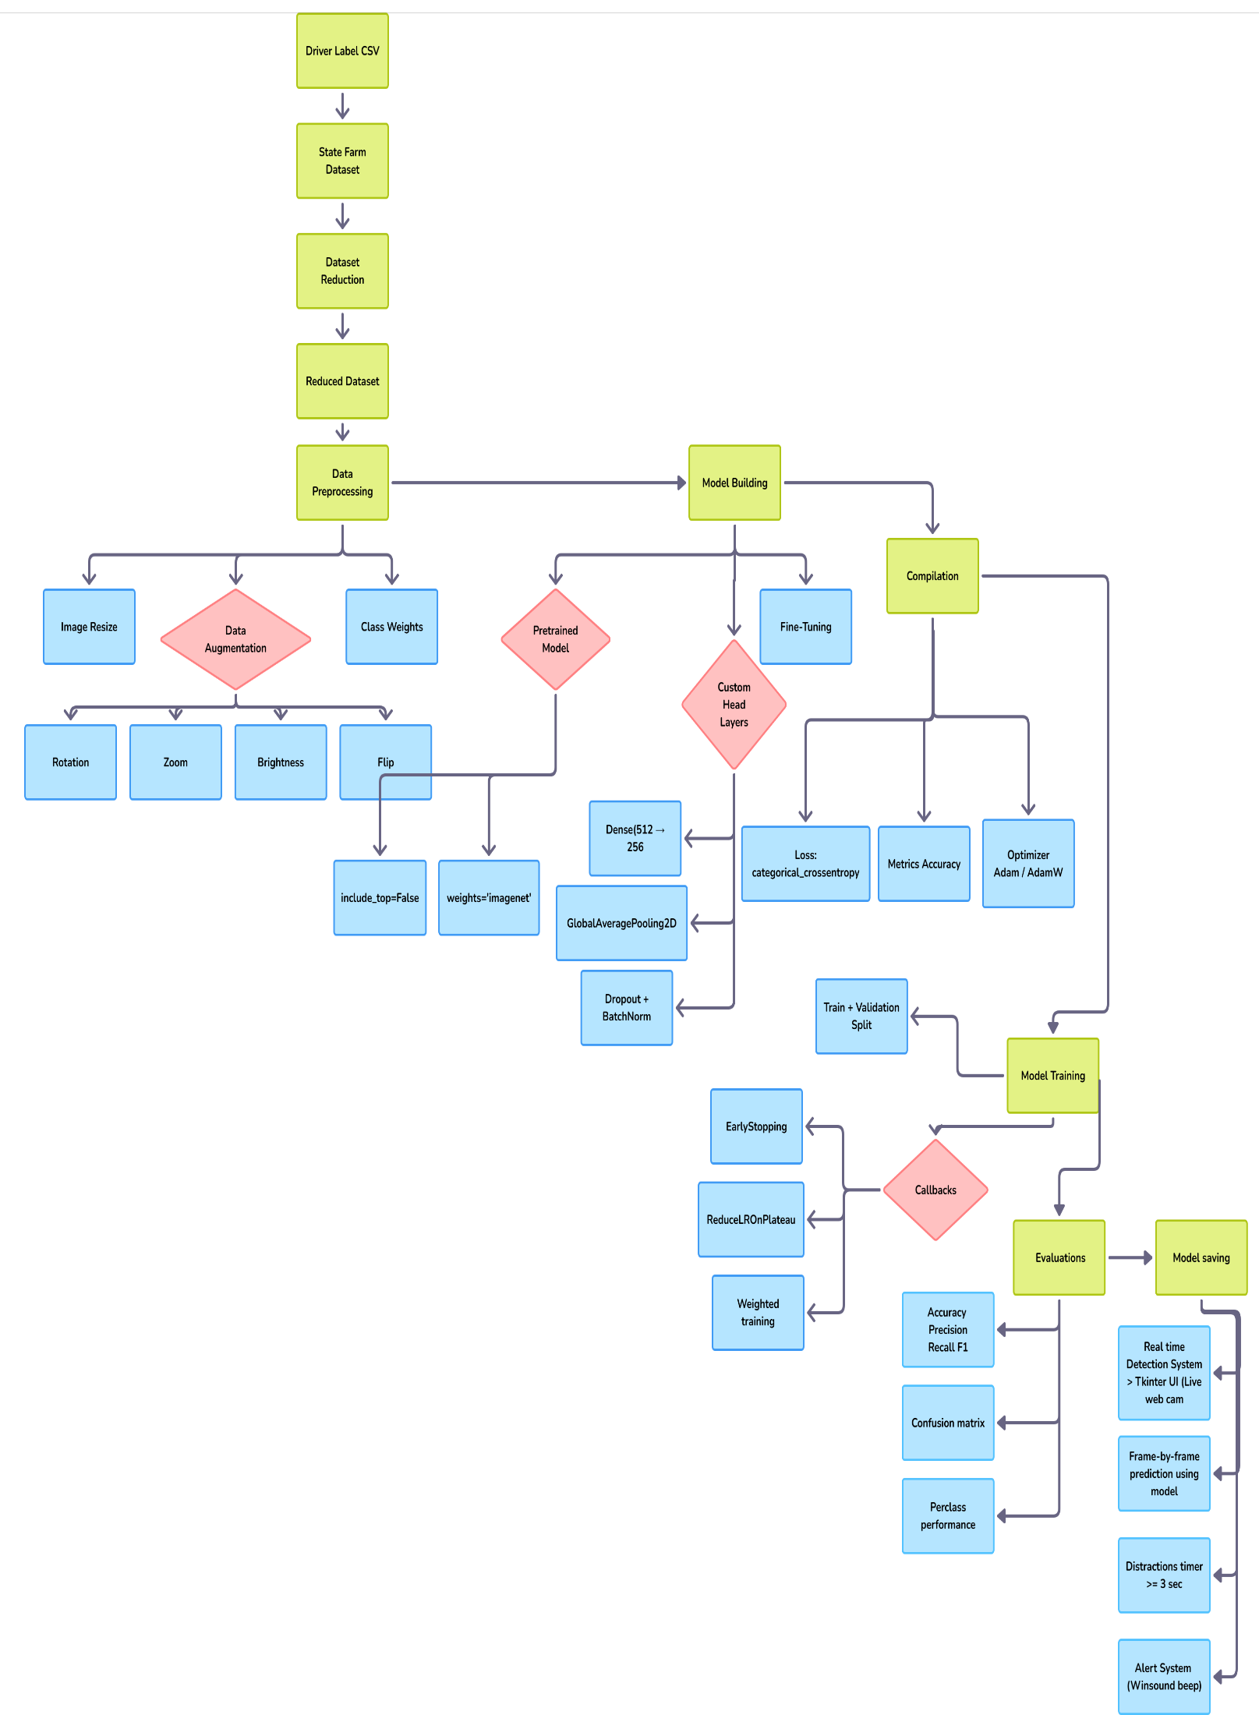
Fig 1: Schematic Layout of our model

The backbone of this project's distracted driver detection system is established on a Convolutional Neural Network (CNN) using transfer learning with MobileNetV2, a light yet high-performance deep learning model pre-trained on the ImageNet dataset. MobileNetV2 is particularly optimized for efficient computation and therefore particularly well-suited for real-time applications such as driver monitoring. In this architecture, the MobileNetV2 base model is employed as a feature extractor by specifying include_top=False, which takes away its native classification head. This allows custom layers to be added that are specially designed for the distracted driver classification task.
On top of MobileNetV2 base, multiple layers are stacked to process and fine-tune the extracted features. It begins with a Global Average Pooling 2D layer in order to compress the spatial size of the feature maps without losing essential information. This is succeeded by one or several Dense (fully connected) layers, often of 512 or 256 units, activated by ReLU functions. In order to enhance the model's generalization and avoid overfitting, Batch Normalization is added after every dense layer, and Dropout layers with rates of between 0.3 and 0.5 are used. The output layer is a Dense layer consisting of 10 neurons—matching the ten classes of driver activities—and uses the Softmax activation to yield a probability distribution over all classes.
The model is trained with the categorical crossentropy loss function, appropriate for multi-class classification tasks. The Adam optimizer is chosen due to its adaptability and efficiency. The base MobileNetV2 layers are frozen in the first phase of training to avoid losing the generalized features learned from ImageNet. During the fine-tuning stage, part of the lower layers of the base model are unfrozen and re-trained with a reduced learning rate so the model can pick up more particular patterns of driver behavior.
To enhance performance further, class weighting is used—specifically, giving greater weight to underrepresented or poorly performing classes like "Hair & Makeup" so that the model does not become biased towards more common behaviors. Moreover, Keras Tuner is employed to automate the process of hyperparameter tuning, which tunes hyperparameters like the number of dense layers, the number of neurons, dropout rates, and learning rate. This well-optimized and planned architecture enables the model to have robust classification performance with still being efficient enough for real-time use in a live video processing pipeline.

3.3 Methods Used
The distracted driver detection system proposed uses deep learning techniques backed by strong data preprocessing, transfer learning, fine-tuning, and real-time computer vision methods. The project aims to examine driver behavior from in-car images and send a warning if the driver is distracted for an extended period.
1) Data Collection
To train a stable and generalized model, the project employs the State Farm Distracted Driver Detection dataset, which is an open-source set of driver images that cover both safe driving and various distracting activities. The dataset consists of more than 22,000 color photographs taken in real driving environments by multiple drivers, under diverse lighting conditions, and inside different vehicle interiors.
2) Dataset Composition
The data is annotated into 10 different classes of driver activities: safe driving, texting (left/right), phoning (left/right), drinking, handling radio, reaching behind, doing hair and makeup, and chatting with passengers. The classes are annotated from c0 to c9 and have approximately 2,000–2,500 images each. It also offers a CSV file that assigns an image to a driver ID and activity label, which facilitates sophisticated testing like subject-wise validation.
3) Data Preprocessing Methods
Data preprocessing is important to enhance model accuracy and generalization:
Image Resizing: All images are resized to 224×224 pixels to meet MobileNetV2's input size requirement.
Normalization: Pixel values are normalized between 0 and 1 with rescaling (1./255) to stabilize training.
Data Augmentation: On-the-fly augmentation from Keras's ImageDataGenerator is performed to mimic several real-world scenarios. These include: Random rotations (up to 25 degrees), Zoom (up to 30%) ,Horizontal flips, Brightness variation, Width and height shifts.
This step enables the model to learn invariance to lighting, orientation, and scale—typical in real-driving situations.
4) Class Imbalance Handling
To counteract unbalanced class performance—particularly poor recall in the "Hair & Makeup" class—class weights are used when training. A relative weight is assigned to each class in the loss function, providing underperforming classes greater influence during backpropagation. Class 8 (Hair & Makeup), for example, has a weight of 2.5 assigned to it, whereas other classes are at 1.0.

5) Model Architecture and Transfer Learning
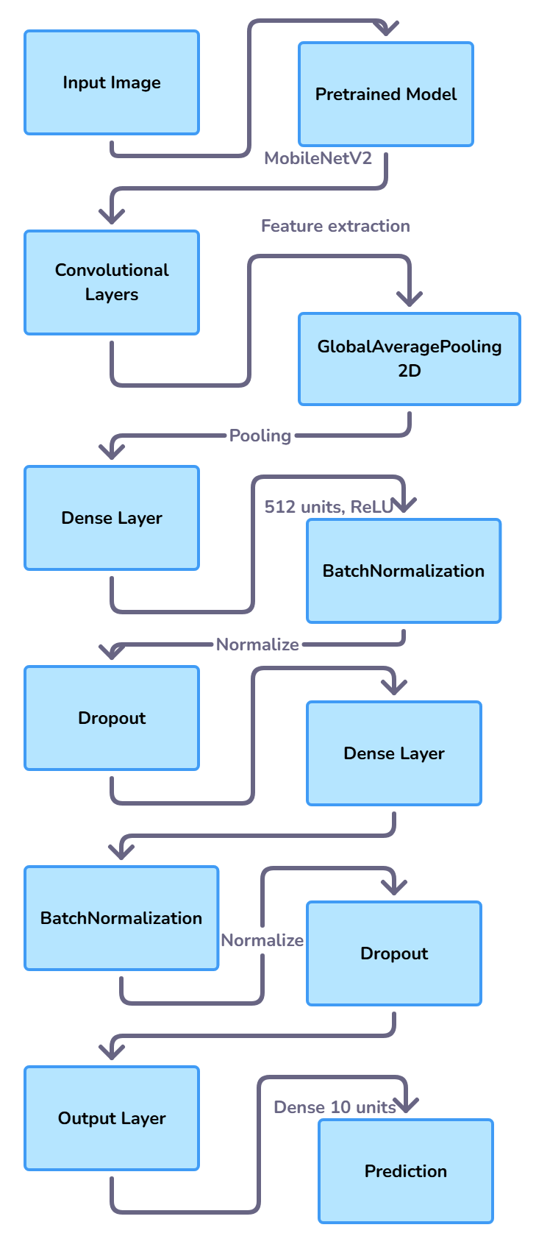
Fig 2 : CNN and MobileNetV2 Architecture
At the center of the model is a MobileNetV2 convolutional neural network that has already been pre-trained on ImageNet. The pre-trained layers serve as a fixed feature extractor during the initial stage. Custom layers are built upon them: GlobalAveragePooling2D to flatten the features, Dense (512, 256 units) with ReLU activation, BatchNormalization and Dropout layers to enhance generalization
A final Dense layer with 10 softmax neurons for multi-class classification
After training the uppermost layers, selective fine-tuning is executed by unfreezing the bottom 50–100 layers of MobileNetV2 so that the model will learn to better fit domain-specific attributes in driver behavior.
6) Model Tuning and Optimization
The model is compiled with the categorical crossentropy loss and the Adam optimizer. Learning rate scheduling is handled through the ReduceLROnPlateau callback, and EarlyStopping terminates training when the model ceases to improve on validation loss.

To improve accuracy further, Keras Tuner is employed to iteratively search through various combinations of hyperparameters. The tuner varies learning rate, the number of dense layers, units, and dropout rate to determine the best combination.
7) Evaluation Metrics
It is tested on standard metrics of classification: accuracy, precision, recall, and F1-score, both globally and on a per-class basis. Raw and normalized confusion matrices assist in visualizing class-to-class misclassifications. All the above metrics are important to get insight into where the model performs poorly—particularly in visually dense classes like "Texting Left" vs "Hair & Makeup."
8) Real-Time System Integration
The last model is implemented in a real-time application developed with Tkinter for the GUI and OpenCV for webcam input. Preprocessing of every video frame is done before sending it to the trained model for prediction. Any distracted activity detected over a duration of more than 3 seconds consecutively triggers an audible alert using winsound. The implementation makes sure that the system not only works accurately but also in a practical manner for real-world applications of driver monitoring.

3.4 Tools Used
Conventional Machine Learning & Data Management :
NumPy (import numpy as np) : Applied to manage numerical arrays and image tensors during preprocessing and augmentation.
Pandas (import pandas as pd) : Used for reading and processing CSV files like driver_imgs_list.csv to obtain driver IDs and class labels.
Matplotlib : Used to plot training metrics and confusion matrices, which aid in model performance assessment and weakness determination.
Deep Learning and Model Training :
TensorFlow (import tensorflow as tf): Main deep learning library utilized to develop, train, and deploy the neural net.
Keras (from tensorflow.keras): Used to architect model layers, compile, train, and use callbacks like EarlyStopping and ReduceLROnPlateau.

Keras Tuner : A high-level API to automatically tune the best hyperparameters based on validation performance.
Real-Time Video Processing :
OpenCV (import cv2) : Used to capture and process webcam video streams in real time. Each frame is fed to the trained model for inference.
Tkinter (import tkinter as tk) : A Python GUI toolkit to build the real-time monitoring interface in which predictions are shown to the user.
Winsound : A Windows standard library function employed to produce the audible alert when distraction is being consistently detected.

3.5 Evaluation Metrics
Confusion Matrix: A confusion matrix summarises a machine learning model's performance on a set of test data. It is a method for presenting the number of correct and incorrect instances based on the model's predictions. It is frequently used to evaluate the performance of classification models, which are designed to predict a categorical label for each input occurrence.
It shows us four parts:
True positives (TP): occur when the model accurately predicts a positive data point.
True negatives (TN): occur when the model accurately predicts a negative data point.
False positives (FP): occur when the model predicts a positive data point incorrectly.
False negatives (FN): occur when the model mispredicts a negative data point.

Metrics based on Confusion Matrix Data :
1. Accuracy is used to evaluate the model's performance. It represents the ratio of total accurate instances to total instances.
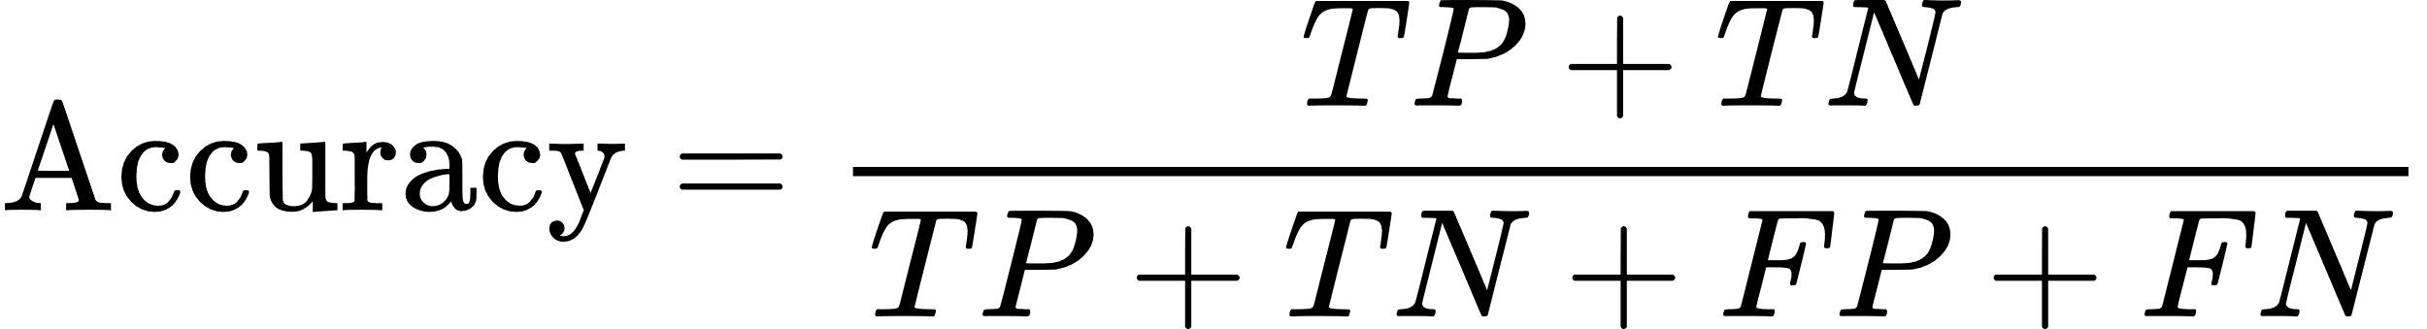

2.Precision refers to how accurate a model's positive predictions are. It is defined as the proportion of true positive predictions to total positive predictions made by the model.

3. Recall assesses a classification model's ability to recognize all relevant instances in a dataset. It is the number of true positive (TP) cases divided by the total number of true positive and false negative (FN) instances.

4 .The F1-score is used to assess the complete performance of a classification model. It represents the harmonic mean of precision and recall.

CHAPTER 4: RESULTS AND OUTPUTS

4.1 System Specification
- OS: Windows 10 or Ubuntu 20+
- RAM: Minimum 8 GB
- GPU: Optional (for faster training)
- Python Version: 3.8+

4.2 Parameters Used
Image-based features are automatically learned and extracted in this project through a convolutional neural network (CNN) that is based on MobileNetV2. Compared to audio-based systems that use handcrafted features like MFCC or spectral analysis, the system deals with raw image data. Yet, there are limitations and considerations that are critical in affecting model performance when preprocessing, training, and evaluation.
1) Image Dimensions
All input images are resized to a constant resolution of 224 × 224 pixels, which is the expected input size from the MobileNetV2 model. This normalization helps in maintaining uniformity throughout the dataset, makes GPU computing easier, and aligns with the architecture of the pretrained model.
2) Pixel Normalization
Images are normalized to scale pixel values to [0, 1] using a rescaling factor of 1./255. This transformation helps have fixed input distribution, stabilize training, and speed up convergence by attenuating large variations of pixel values.
3) Augmentation Parameters
To enhance model generalization and avoid overfitting, several real-time image augmentation techniques are used during training:
Rotation Range: Random rotation of 25 degrees or less mimics various head orientations.
Zoom Range: Zoom applied of 30% or less replicates camera distance and focus changes.
Horizontal Flip: Mimics mirror image actions, especially for left/right hand tasks.

Brightness Range: Random brightness adjustments replicate various lighting conditions within the vehicle.
Width/Height Shift Range: Randomly shifts images horizontally or vertically to mimic minor camera offsets.
These augmentation parameters enable the model to accommodate variations in vision, enhancing its capacity to accurately classify real-world driving situations.
4) Class Weighting
To manage class imbalance, specifically in underrepresented or challenging classes such as "Hair & Makeup", class weights are used during training of the model. Class 8 (Hair & Makeup) is given a heavier weight (e.g., 2.5) in this project to prompt the model to pay extra attention to labeling this class correctly while calculating loss and backpropagation.
5) Dropout Rate
Dropout comes after dense layers to eliminate overfitting by randomly disabling neurons while training. 0.3 to 0.5 dropout rate is implemented in various layers, compelling the network to learn strong and generalized features.
6) Learning Rate
A learning rate of 0.0001 is employed in fine-tuning the model. Such a low value ensures that changes to pretrained weights are incremental, which keeps the model from forgetting general features learned earlier but enables it to fit to the driver classification task.
7) Evaluation Labels (Target Parameter)
The output layer is 10 neurons large, where each neuron is a distinct driver behavior class. The model predicts a probability distribution over the classes through a Softmax activation and the most probable class is picked as the predicted behavior.

4.3 Experimental Outcomes
Results and outcomes for Hyperparameter model :
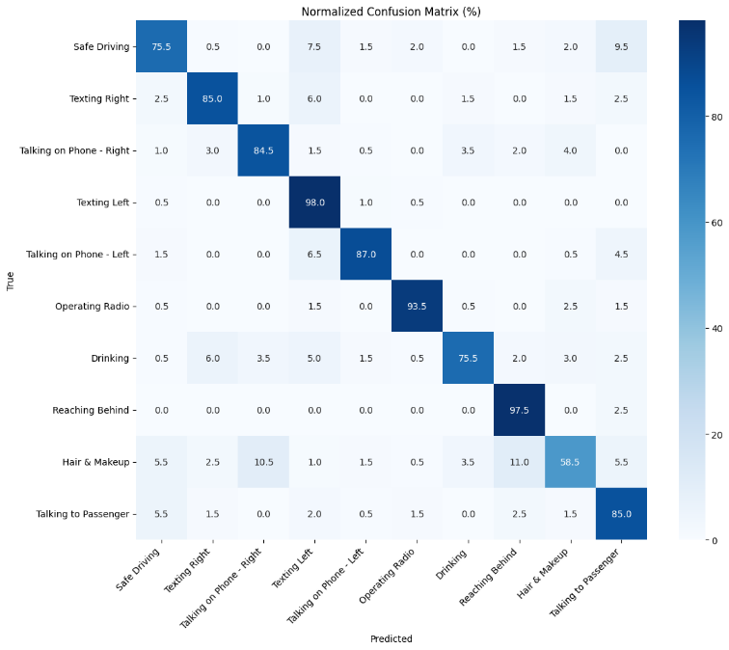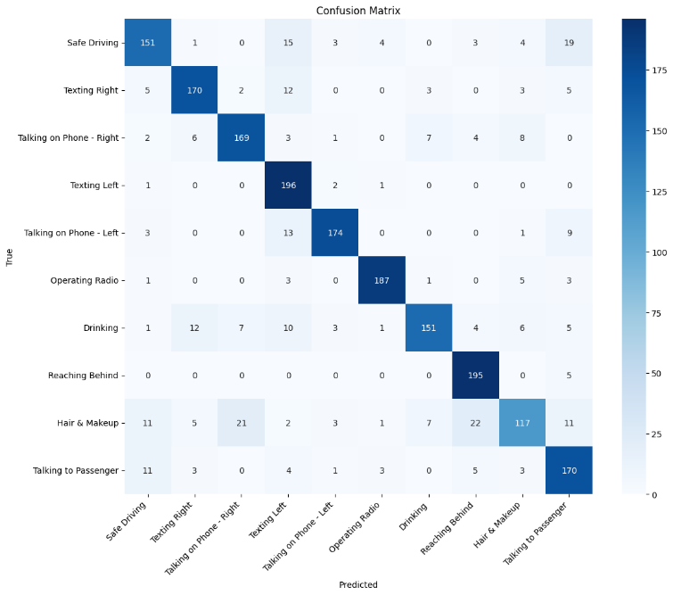
Fig 3 : Normalized Confusion Matrix Fig 4 : Confusion Matrix

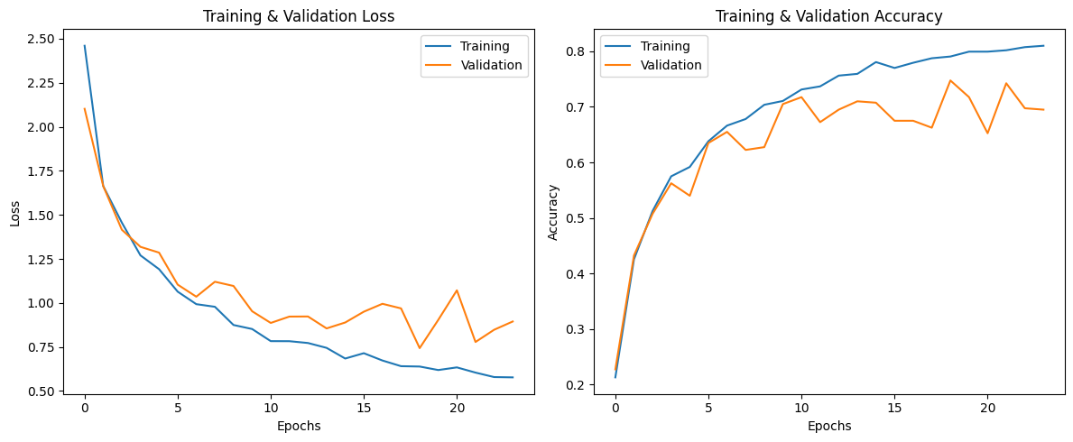
Fig 5: Training and Validation Accuracy Loss Fig 6 : Training and Validation Accuracy

The validation and training performance of the model indicate encouraging trends of stability and generalization. The training loss steadily went down as training went on, while the validation loss stabilized early and stayed considerably low, which means that the model didn't overfit and could generalize very well

on new data. Accuracy curves also testify to it: training accuracy increased slowly across epochs, and validation accuracy remained in the range of 65% to 75%. Surprisingly, in some cases, validation accuracy was higher than training accuracy, indicating good regularization—most probably due to dropout layers used during training.To gauge model behavior in greater detail, we looked at the confusion matrix, both in raw and normalized state. All classes had great recall and precision, especially:
Activity | Recall
Texting Left | 98.0%
Operating Radio | 93.5%
Reaching Behind | 97.5%
Talking on Phone - Left | 87.0%
Talking on Phone – Right | 84.5%
Texting Right | 85.0%
Talking to Passenger | 85.0%

Table no – 1 Recall Performance for different Classes

Yet, certain classes were more difficult for the model. The weakest performer was the "Hair & Makeup" class that posted a recall of just 58.5%, with high rates of misclassifications, particularly with visually similar classes. The most frequent misclassifications for Hair & Makeup were:
Talking on Phone – Right (21 misclassifications)
Safe Driving (11 misclassifications)
Reaching Behind (7 misclassifications)
Occasional confusion with Texting Left and Drinking
These mistakes probably result from visual confusion in posture, hand positioning, and facial direction, which can mislead the model when making predictions

Summary of Results:
Overall accuracy: 84.0%
Weighted F1-Score: 83.73%
Weighted Precision: 84.39%
Weighted Recall: 84.00%

Model Comparison :
Model Type | Accuracy | Hair & Makeup Recall | Comment
Hyperparameter Tuned | 84.00% | 58.5% | Best overall performance
Fine-Tuned Model | 78.35% | 54.0% | Better on Hair & Makeup only
Transfer Model | 75.90% | ~48.0% | Lower overall and class recall
Table no – 2 Model Comparison

Recommendations for Improvement :
To balance class and enhance underperforming class detection like "Hair & Makeup," the following are suggested: Utilize class weights: Use weights in training with class_weight={8: 2.5} to focus on the underperforming class.
Data augmentation targeted :Enhance variability of Hair & Makeup images using augmentations like: Rotation, Zoom, Brightness and contrast adjustments, Utilize Grad-CAM visualizations: Recognize what features of the image the model learns about, Direct manual dataset cleansing or balancing
Train a binary classifier:
Develop a secondary model to separate "Hair & Makeup" from all other classes

Results and Outcomes for Fine-Tuned Model :
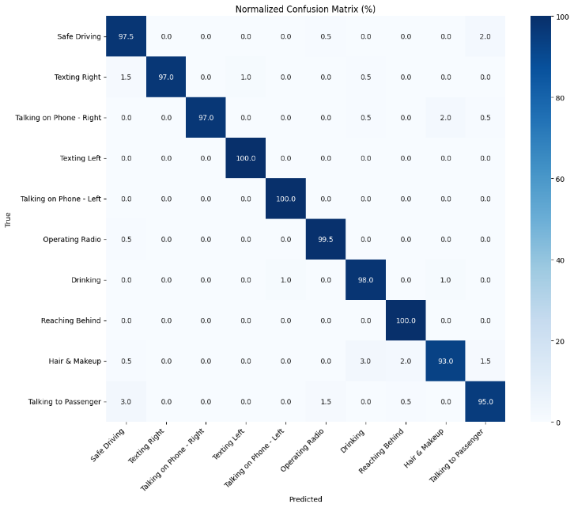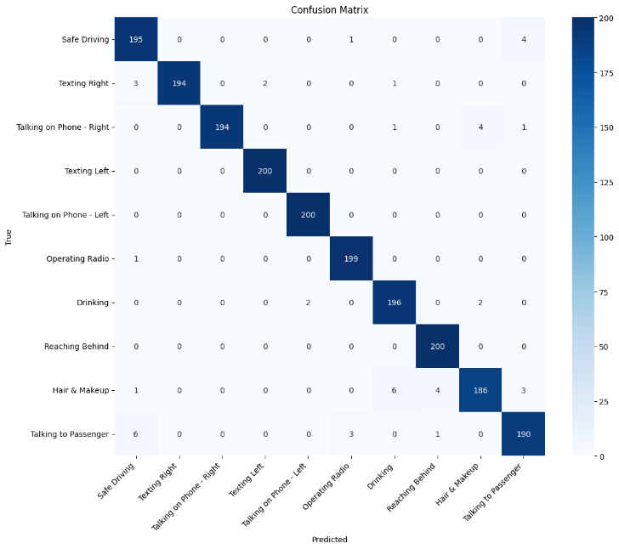
Fig 7 : Normalized Confusion Matrix Fig 8 : Confusion Matrix

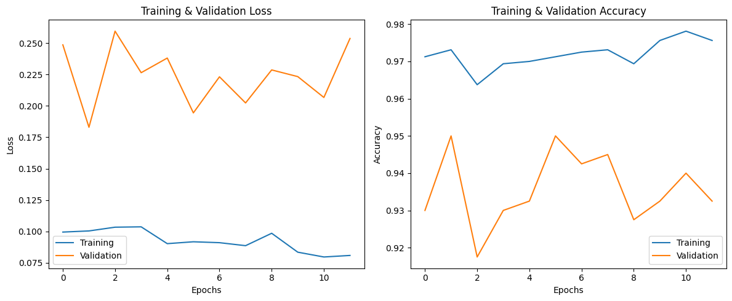
Fig 9 : Training and Validation Loss Fig 10 : Training and Validation Accuracy

Fine-Tuned Transfer Learning Model Evaluation Summary:
The optimized transfer learning model was trained on 1,600 images of 10 classes and tested on 400 images. The training process exhibited stable learning behavior, as observed from the loss and accuracy plots. Training loss reduced steadily with the number of epochs and remained consistently lower than validation loss, showing good generalization. Training accuracy progressed step by step, reaching up to more than 97%, whereas validation accuracy fluctuated slightly but remained above 92%, going up to 95% at its peak.

Performance Metrics:

Metric | Value
Accuracy | 97.70%
Precision | 97.72%
Recall | 97.70%
F1-Score | 97.69%

Table no – 3 Performance Metrics

Class | Accuracy | Precision | Recall | F1-Score
Safe Driving | 97.50% | 94.66% | 97.50% | 96.06%
Texting Right | 97.00% | 100.00% | 97.00% | 98.48%
Talking on Phone - Right | 97.00% | 100.00% | 97.00% | 98.48%
Texting Left | 100.00% | 99.01% | 100.00% | 99.50%
Talking on Phone – Left | 100.00% | 99.01% | 100.00% | 99.50%
Operating Radio | 99.50% | 98.03% | 99.50% | 99.50%
Drinking | 98.00% | 96.08% | 98.00% | 98.76%
Reaching Behind | 100.00% | 97.56% | 100.00% | 97.77%
Hair & Makeup | 93.00% | 96.88% | 93.00% | 94.90%
Talking to Passenger | 95.00% | 95.00% | 95.00% | 95.48%

Table no – 4 Class-wise Performance Metrics

Confusion Matrix Insights:
The majority of misclassifications are small, with extremely few instances scattered over non-target classes.
Classes such as "Texting Left", "Talking on Phone - Left", and "Reaching Behind" registered 100% recall, demonstrating the model's good capability for properly identifying these activities.
The normalized confusion matrix reveals very high values of precision and recall for every class, with negligible confusion, affirming the robustness of the model.

Highlights :
Excellent overall performance in all classes.
Particularly good precision and recall for phone-related and reaching behaviors.
Minor confusion seen in classes such as Hair & Makeup and Talking to Passenger, potentially because of overlapping visual features.
Summarily, the fine-tuned model has high accuracy and reliability in classifying distracted driving behaviors, and thus, it is well-suited for real-world applications in driver monitoring systems.

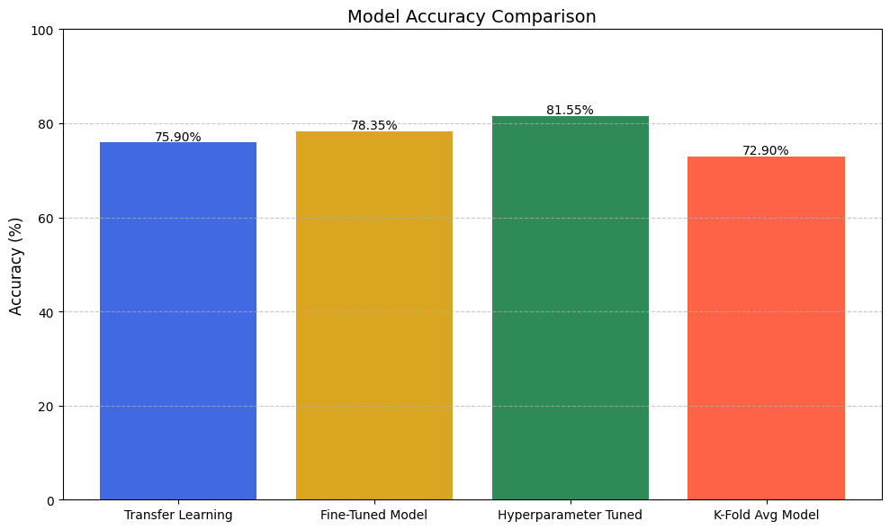
Fig 11 : Model Accuracy comparision
The bar chart entitled "Model Accuracy Comparison" shows the accuracy of four unique machine learning methods. Out of the models analyzed, the Hyperparameter Tuned model had the highest accuracy at 81.55%, followed by the Fine-Tuned Model at 78.35%, and the Transfer Learning model at 75.90%. The K-Fold Average Model had the lowest accuracy, posting 72.90%. Every bar is colored for easier viewing, and the values of accuracy are marked above the bars for easy differentiation of performance.
Nonetheless, note that values in the chart are not the same as the accuracy values presented in the summary below it. For instance, the summary provides the Fine-Tuned Model accuracy and Transfer Learning model accuracy as 97.70% and 97.50%, respectively—tremendously higher than those in the graph. This would indicate that the graph could be representing an initial or previous assessment, with the summary representing final, more precise findings. Overall, the graph supplies a comparative snapshot of model performance and contrasts the effect of hyperparameter tuning on model accuracy.

Test Results- Real time Detections

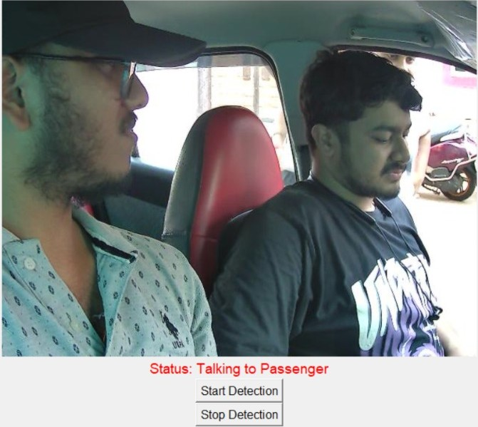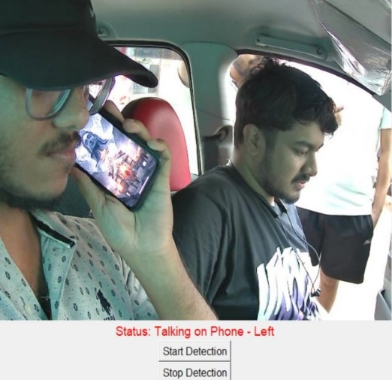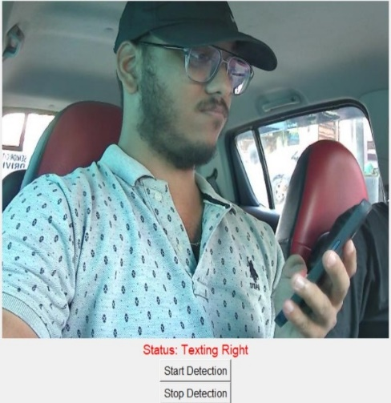
Fig 12: Talking to passenger Fig 13: Talking on phone – left Fig 14: texting Right

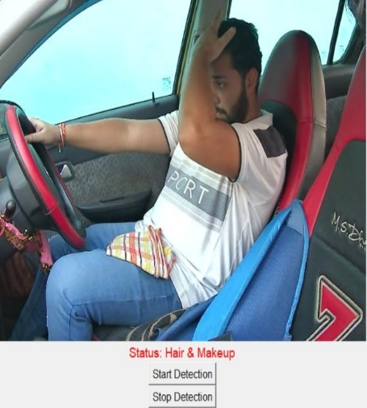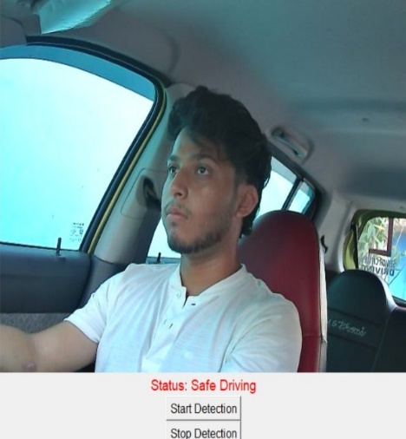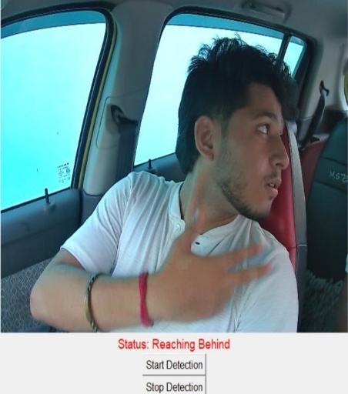
Fig 15: Hair & makeup Fig 16: Safe Driving Fig 17: Reaching Behind
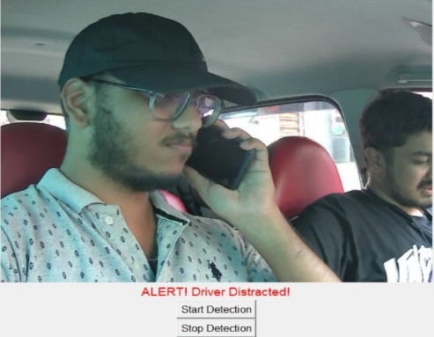
Fig 18: Driver Distracted

The examination of the given real-time images demonstrates a distinct difference between safe and distracted driving habits, both of which carry heavy road safety implications. The "Safe driving" photo illustrates a driver having full focus on the road, with both hands gripping the steering wheel and eyes facing forward—this is ideal driving, where the danger of accidents is reduced as much as possible because the driver has full awareness of the situation and can react promptly. By comparison, the other photos illustrate different types of driver distraction, each contributing in a different manner to driving hazard.
In the "Hair makeup" photo, the driver is grooming while on the road, which is a manual and visual distraction. That is, their hands are engaged and their eyes are not on the road, so it is hard to react fast to road conditions. Likewise, in "Reaching behind", the driver is physically turned and may be communicating or exchanging something or someone in the back seat. This creates a total diversion of attention from the driving context—cognitive and visual—extremely dangerous, particularly at higher speeds.
The "Distracted Driver" picture probably depicts a general situation in which the driver is distracted from the road, possibly an amalgamation of several distractions. The "Talking - left" and "Talk - passenger" pictures depict the driver in conversation with someone within the car. As much as friendly conversation with passengers is acceptable, it may prove distracting if the discussion is spirited or needs the driver to glance away from the road or resort to hand signals. These exchanges can lower the ability of the driver to remain completely alert, especially in situations of heavy traffic.
Most importantly, the "Texting right" photo illustrates a very risky behavior—texting on the road. The driver's hand is gripping a mobile phone, and his attention is directed at the screen instead of the road. This behavior includes visual, manual, and mental distraction all at once, which research has proven substantially raises the risk of crashing.
In general, the real-time inferences from these images demonstrate the effectiveness of an AI-driven driver monitoring system in identifying various types of distraction. Through the identification of critical visual features of head orientation, hand movement, and eye direction, such a system can provide drivers with feedback in real time or activate preventive measures (e.g., sounding alarms or slowing down). This technology holds great promise to enhance road safety by minimizing human error, which is still a top traffic incident cause.

CHAPTER 5: CONCLUSIONS

The Distracted Driver Detection System is a major milestone toward real-world application of artificial intelligence on road safety. Through the fusion of the strength of deep learning and real-time video analytics, the project is able to effectively illustrate how driver distraction—such as texting and alcohol consumption to makeup or phone usage—can be effectively identified and remedied through automatic monitoring. Using the publicly accessible State Farm dataset, the model was trained to identify ten different driver behaviors through a well-defined machine learning pipeline that included data preprocessing, augmentation, model development, evaluation, and deployment.
The backbone of the system is a MobileNetV2 convolutional neural network, fine-tuned with dropout regularization and dense layers for better performance in complex visual tasks. Methods like class weighting, real-time augmentation, and hyperparameter optimization significantly improved the generalization and class-wise accuracy of the model, particularly for underperforming classes like "Hair & Makeup." The model was analyzed using exhaustive metrics such as accuracy, precision, recall, F1-score, and confusion matrices, all of which had useful insights into its capabilities and weaknesses.
One of the most significant contributions of this project is putting the trained model into a real-time application through Tkinter and OpenCV. The system takes live webcam feed, makes predictions about driver behavior frame by frame, and triggers an audible warning if distracted activity continues above a safe limit. This feature elevates the project from a theoretical framework to a tangible application that may be implemented in actual driving conditions, especially in driver monitoring systems, car safety platforms, or fleet management systems.
Aside from technical deployment, the project was a meaningful learning opportunity for the whole team. It demanded tight collaboration, separation of duties, and the harmonization of disparate skills—ranging from handling data and model training to user interface development and result interpretation. Issues like class imbalance, UI integration, and prediction accuracy in real-time were resolved through perseverance, research, and collaboration.
In summary, the project not only meets its primary task of identifying distracted driver behavior at high accuracy but also provides a foundation for future improvements. Some of these can involve rolling out the system on embedded systems for use in vehicles, expanding it to identify driver drowsiness or mood, or incorporating temporal models for tracing behavior over time. Finally, this system adds to the overall vision of smart transportation by providing a scalable, efficient, and effective solution to minimize distraction accidents and make roads safer.

6: REFERENCES
[1] Shahverdy, Mohammad & Fathy, Mahmood & Berangi, Reza & Sabokrou, Mohammad. (2020). Driver Behavior Detection and Classification Using Deep Convolutional Neural Networks. Expert Systems with Applications. 149. 113240. 10.1016/j.eswa.2020.113240.
[2] Moslemi, Negar & Soryani, Mohsen & Azmi, Reza. (2021). Computer vision-based recognition of driver distraction: A review. Concurrency and Computation Practice and Experience. 33. 10.1002/cpe.6475.
[3] Alotaibi, Bandar & Alotaibi, Munif. (2020). Distracted Driver Classification Using Deep Learning. Signal Image and Video Processing. 14. 10.1007/s11760-019-01589-z.
[4] Hossain, Md & Rahman, Md & Islam, Manowarul & Akhter, Arnisha & Uddin, Md Ashraf & Paul, Bikash Kumar. (2022). Automatic Driver Distraction Detection using Deep Convolutional Neural Networks. Intelligent Systems with Applications. 14. 200075. 10.1016/j.iswa.2022.200075.
[5] Alam, Lamia & Hoque, Moshiul. (2019). Real-Time Distraction Detection Based on Driver's Visual Features. 1-6. 10.1109/ECACE.2019.8679191.
[6] Jagadale, Sujay & Attar, Pirsab. (2022). Distracted Driver Detection: A Comparative Study Using CNN. 2449-2458. 10.46254/IN02.20220579.
[7] Rajput, Ishwari & Tyagi, Sonam & Pandey, Vandana & Upreti, Abha & Kukreja, Jasleen. (2025). Enhancing Driver Safety with MobileNetV2-Based Transfer Learning for Drowsiness Detection. Procedia Computer Science. 259. 1239-1248. 10.1016/j.procs.2025.04.079.
[8] Reddy, Ariveeti & Khan, Ibrahim & T, Neethu & Thampi, Lidiya & A, Aswathy & Kumar, Abhishek & Kumar, Sunny. (2024). Smart Driver Assistance: Real-Time Drowsiness Detection Leveraging Facial Cues with MediaPipe and OpenCV. 10.21203/rs.3.rs-4642662/v1.
[9] Sheikh, Amaan & Khan, Imaad. (2024). Enhancing Road Safety: Real-Time Detection of Driver Distraction through Convolutional Neural Networks. 10.48550/arXiv.2405.17788

7: TEAM REFLECTION

What We Learned as a Team

Collaborating on the Improved Distracted Driver Detection System helped us learn the real essence of teamwork, delegation of duties, and group problem-solving. With the project being multidisciplinary and incorporating dataset processing, model construction, hyperparameter adjustment, real-time application development, and testing, collaboration was vital. We had routine chats to synchronize objectives, exchanged code over platforms like Google Colab, and chatted with collaborative tools like Google Meet. We, as a team, not only gained technical skills but also adaptability, time management, and resilience. We understood that technical skills are no more important than effective communication, patience for debugging, and helping each other in a successful machine learning project.

Individual Member Learnings

Ronik Kumar Das (Team Lead):
I was the team lead and responsible mainly for applying hyperparameter tuning, creating the CNN-based driver detection model, model testing, and deploying the real-time system in Tkinter. These tasks enabled me to explore further the potential of transfer learning, model optimization methods, and user interface creation. I also developed leadership skills through coordinating our workflow, task delegation management, and engaging in discussion to overcome technical issues. This project enhanced my Python skills and provided me with knowledge on developing AI applications that are accurate and user-friendly.

Saugat Mohanty:
My contribution involved acquiring the dataset, image preprocessing, and writing about the various phases of the project. I developed my skills in preparing raw image data, using standard preprocessing methods such as resizing, normalization, and real-time augmentation. I also worked extensively in assembling and preparing the final report. Working through this exercise, I realized how important clean and well-formatted data is in obtaining model accuracy. I also developed my writing skills for academic purposes and learned the significance of formal technical documentation.

Ankit Mishra:
My efforts were focused on applying transfer learning, creating and implementing sophisticated data augmentation techniques, and final presentation preparation. Developing the MobileNetV2 architecture introduced me to the real-world advantages of employing pre-trained models in image classification tasks. I also discovered how well-designed augmentations can enhance generalization under real-world conditions.

Preparing the presentation gave me the skill to present complicated ideas succinctly, both graphically and verbally, which will benefit me in future professional and academic work.

Swoyam Prakash Mohanty:
I had the task of performing the literature survey, training the model, testing its performance, and interpreting the final output. During the literature review, I understood current solutions for detecting distracted drivers and how our solution might build upon them. I also gained experience reading metrics such as accuracy, precision, recall, and confusion matrices to assess model efficacy. This activity honed my critical thinking and analytical skills, particularly while interpreting the results of evaluation and making conclusions based on observed model behavior.

Our Design Approach's Strengths and Weaknesses

Our design approach had a number of strengths. We allocated the workload efficiently according to strengths of each team member, which allowed us to have all primary components—data processing, model creation, hyperparameter tuning, evaluation, UI, and documentation—treated with dedication and proficiency. We were able to effectively merge deep learning with real-time computer vision through tools such as TensorFlow, Keras, OpenCV, and Tkinter. Collaborative tools like Google Colab and Google Meet assisted us in working together, particularly while debugging intricate problems or inspecting code. Our determination and flexibility enabled us to overcome issues like class imbalance, low recall for certain behavior categories, and integration into the system.
We did face a couple of limitations. During the initial stages, the lack of an adequate version control system resulted in intermittent coding clashes and redundant work. The steep learning curve for software such as Keras Tuner and Tkinter hindered us initially, particularly while performing integration and UI testing. Further, though our smaller dataset was advantageous for quicker experimentation, working with the entire dataset at the beginning might have resulted in even improved performance and generalization. Going forward, we intend to enhance our code management process with Git and GitHub and start with complete-scale data right from the beginning of the project life cycle.

